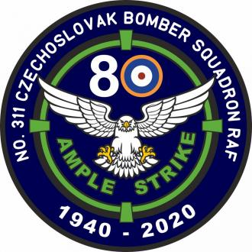
Last Name: |  |  |  | Access badge no.*:
First Name: | Passport/ID Card:
Nationality: | Press card no.:
Agency: | Web:
Business Address
Street: | Postal Code:
City: | Country:
Phone number: | E-mail:
Type of media activity  If you cross “Other”, specify in Remarks. | Press | Radio | TV |  | Other
Remarks:

Interested media representatives are asked to electronically fill in the form and send it to
Ample Strike 2020 Joint Media Information Centre at amse.jmic@army.cz
The data obtained with this registration is only for JMIC Public Affairs purposes. *Access badge number will be filled in by Public Affairs staff.

